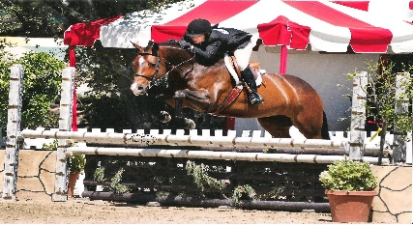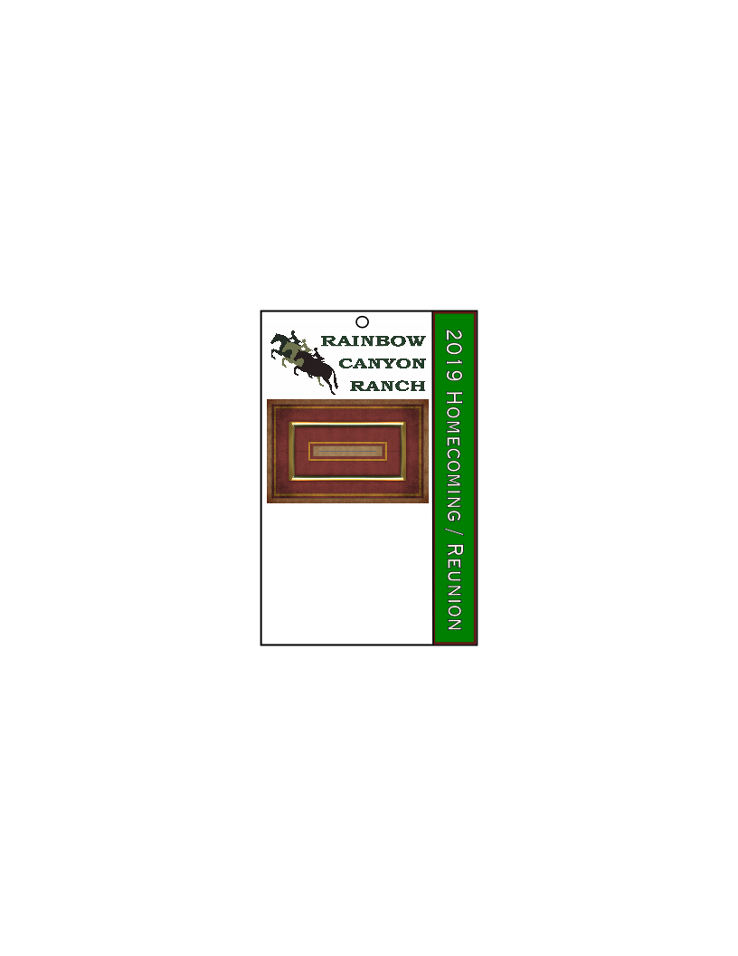

***Other Name Here***

***“Horses Name Here”***

***Years spent at RCR***

***Type Name Here***

Directions:

1. Right click on the Air Amateur photo- choose- Change picture- Replace with one of yours from your computer. You may need to use the crop tool to make it fit
2. Line one – Your Current Name
3. Line two- The name you used when you were at RCR- ie. Maiden name- if name is the same then delete text
4. Horse or horses name you rode or owned
5. Enter years at RCR
6. Print on nice strong paper- or even better laminate after printing.
7. Punch hole at top where circle is
8. Attach string or to lanyard cord
9. Wear proudly to Homecoming/Reunion so everyone knows who you are.

***“All that Gliters”***

***Kim Tasker***

***1988-2019***

Example:

Rainbow Canyon Ranch Homecoming/Reunion Badge